Farmer’s Market Vendor Cooperative Management System - Business Description
INET 4707
Kenneth Keopraseuth, Aishwarya Ramkumar, Ruqia Abdiwahab, Ilya Shkurko, John Xiu
May 03, 2025

Overview

Business Name: Farmer’s Market Vendor Cooperative Management System
Industry: Community Agriculture and Market Operations

The Farmers’ Market Vendor Cooperative connects independent local vendors with the community by offering a centralized platform to sell local produce, crafts, and handmade goods. The market has operated through manual processes to manage vendor registrations, stall assignments, inspections, payments, and sales tracking, leading to inefficiencies and missed opportunities for optimization.
To address these challenges, we initiated a comprehensive project to modernize operations by implementing a database-driven management system. This system is designed to automate key business processes, improve record-keeping accuracy, streamline compliance tracking, and enable data-driven decision-making.

Business Need
Managing a growing vendor base while maintaining quality, safety, and financial tracking is becoming more complex than before. Manual systems struggle with:
- Tracking stall bookings and vendor assignments across market days.
- Monitoring vendor performance, sales figures, and customer attendance.
- Ensuring vendors meet inspection and health compliance requirements.
- Managing timely payments and addressing attendance no-shows.
In addition to operational inefficiencies, rising concerns about cybersecurity risks in vendor and customer data management prompted the parallel development of an IT security improvement initiative.

Project Goals

- Database System Implementation: Build and deploy a relational database system covering vendors, stall bookings, sales, inspections, attendance, and market days.
- Automation: Replace manual tracking with automated workflows for permit checks, compliance audits, and vendor performance reporting.
- Security Enhancements: Protect vendor and customer data through infrastructure improvements like firewalls, IDS/IPS systems, SIEM integration, and staff training in cybersecurity best practices.
Strategic Objectives
- Improve Operational Efficiency: Centralize all vendors, sales, and event information into a digital platform.
- Enhance Compliance Management: Automatically track inspections and regulatory requirements.
- Optimize Vendor Performance: Use key performance indicators (KPIs) such as no-show rates, sales per market day, and inspection compliance to drive better vendor engagement.
- Ensure Data Security: Strengthen IT infrastructure through structured security evaluation, compliance checks, continuous monitoring, and staff cybersecurity training.

Key Milestones
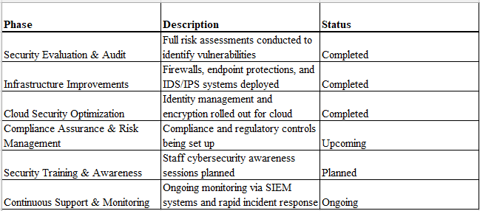

Final Vision
Through database-driven management and strengthened security operations, the Farmers’ Market will offer a safer, more efficient, and more transparent experience for vendors, staff, and the community, setting a standard for modern farmers' market operations.

